**BCSE203E WEB PROGRAMMMING**

**LAB EXERCISE -1**

**TEXT, IMAGE ,LINKS**

**NAME: M.MENMANGAI**

**REGISTRATION NO: 23BCE1022**

**1) Design a webpage (home.html) with the following features**

**a. Display your name in blue color using the Verdana font in the screen. Set the webpage title as "Welcome to my page - [Your Registration Number]".**

**b. Print alphabets from A to F on the screen from the smallest to largest font, each letter styled with a different font and color.**

**c. Display your first name in bold, middle name in italics and last name in underlined font format.**

**d. Write and display two paragraphs that describes your ambition and hobbies.**

**• Highlight the ambition text with a yellow background.**

**• Italicize and bold the hobbies text.**

**b. Add a comment line in your HTML code. Ensure it does not appear on the webpage.**

**c. Display the following equations on the page:**

**⚫ (a-b)-a2-2ab+b2**

**• 2H2+O2-2H2O**

**d. Display a C program that prints your account number and balance (include the * (Rs.) symbol.)**

**e. Set an image as the background of the webpage**

**f. Apply marquee to display your roll number**

**g. Insert a passport sized image aligned to the right side of the screen**

**h. Use a <div> tag to display two separate paragraphs.**

**i. Create the link at the bottom of the page and move from bottom to top onclick**

**j. Create a "mailto" link to any email-id**

**k. Use acronym, meter, progress bar and summary tags on your page**

**CODE:**

**home.html :**

<!DOCTYPE html>

<html>

    <head>

            <title>

                Welcome to my page - 23bce1022

            </title>

            <style>

                body {

                    background-image: url('rainbow-bokeh-soft-light-abstract-background-eps-10-illustration-bokeh-particles-background-decoration-vector.jpg');

                    animation: backgroundGradient 10s ease infinite;

                }

            </style>

    </head>

    <body>

            <h1  style="color:blue;font-family:Franklin Gothic Medium;font-size: 50%;">A</h1>

        <h2  style="color:rgb(7, 7, 4);font-family:Times New Roman;font-size: 70%;">B</h2>

        <h3  style="color:rgb(0, 255, 128);font-family:Courier New;font-size: 90%;">C</h3>

        <h4  style="color:rgb(161, 69, 138);font-family:Arial;font-size: 110%;">D</h4>

        <h5  style="color:rgb(255, 81, 0);font-family:sans-serif;font-size: 130%;">E</h5>

        <h6  style="color:rgb(255, 38, 0);font-family:Impact;font-size: 150%;">F</h6>

        <H7 style="font-family:verdana;color:blue;font-size: 300%;">

            My name is M Menmangai

         </H7><br>

         <h8 style="font-size: 150%;"><b>M</b></h8>

         <h9 style="font-size: 150%;"><i>Menmangai</i></h9>

         <h8 style="font-size: 150%;"><u>Muthukumar</u></h8>

         <br><br>

         <h9 style="font-size: 100%;"><u>My Ambition</u></h9>

         <p style="background-color: yellow;">My ambition is to either clear UPSC in my first attempt and become an IAS officer to serve my country or to find a high-paying job overseas.</p>

         <br><h10 style="font-size: 100%;"><u>My Hobbies</u></h10>

         <p><b><i>My hobbies are drawing, mostly potraits. It calms my mind when I am feeling stressful. Singing, cooking my fav dishes , reading novels, watching animes and gaming</i></b></p>

         <!--This is a comment line. Ignore this line-->

         <br><br>

         <h11 style="font-size: 100%;"><u>Using superscript and subscript</u></h11>

         <p>(a-b)<sup>2</sup>=a<sup>2</sup>-2ab+b<sup>2</sup><br>2H<sub>2</sub>+O<sub>2</sub>=2H<sub>2</sub>O</p>

         <br><br><h12 style="font-size: 100%;"><u>Using pre and code tag to display C program </u></h12>

         <pre><code style="font-size: 100%;">

            int acc_number =023452896;

            int balance = 40768

            printf("The account number %d has %d amount in it.",acc_number,balance);

         </code></pre>

         <br><br><h13 style="font-size: 100%;"><u>Using marquee tag to display registration number</u></h13><br>

         <marquee behavior="alternate" font-size="300%">23BCE1022</marquee>

         <br><br><h16 style="font-size: 100%;"><u>Using acronym tag</u></h16>

         <p>The <acronym title="World Wide Web">WWW</acronym> is only a component of the

            Internet.</p>

    <br><br><h17 style="font-size: 100%;"><u>Using meter tag</u></h17><br>

    <p>Disk usage: <meter value="75" min="0" max="100" low="30" high="70" optimum="50">75%</meter></p>

    <p>Battery level: <meter value="0.6" optimum="0.8">60%</meter></p>

    <br><br><h18 style="font-size: 100%;"><u>Using progress tag</u></h18><br><br>

    <label for="upload-demo">Uploading file:</label>

<progress id="upload-demo" value="0" max="100"></progress>

<script>

const progress = document.getElementById('upload-demo');

let value = 0;

const val = setInterval(() => {

    if (value >= 100) {

        clearInterval(val);

    } else {

        value=value+0.5;

        progress.value = value;

    }

}, 100);

</script><br><br>

<h19 style="font-size: 100%;"><u>Using mailto tag to send immediate emails</u></h19><br><br>

         <a href="mailto:kavimuthu07@gmail.com,mathimangaimk@gmail.com?subject=Hello%20,this%20is%20M%20Menmangai.">Send email</a>

         <br><br>

<br><br><h20 style="font-size: 100%;"><u>Using summary tag to hide info</u></h20>

    <details>

        <summary>Click to view more information</summary>

        <p>This is the hidden content that appears when you click the summary.</p>

        <ol>

            <li>Web programming is fun!</li>

            <li>Web programming is the use of coding to develop websites and web applications that are hosted on the internet. </li>

            <li>Web programmers also design user interfaces, ensure browser compatibility, and maintain web security.</li>

        </ol>

    </details>

<br><br><h22 style="font-size: 100%;"><u>Using img tag to insert my passport photo</u></h22>

        <img src="C:\Users\Muthukumar Natesan\Downloads\23bce1022\menmangai.jpg" alt="Mangai" width="100" height="150" align="right">

        <br><br><h23 style="font-size: 100%;"><u>Using div tag to write 2 separate paragraphs</u></h23><br>

        <div>This paragraph is made using the first division tag.</div><div>This is made using the second division tag.</div>

        <br><br><h22 style="font-size: 100%;">Feel free to view our e-greeting page</h22>

        <br><nav>

            <a href="greeting.html">View Our E-Greeting</a>

        </nav>

        <br><br><h23 style="font-size: 100%;"><u>Using anchor tag to go back to the top</u></h23><header>

        <footer>

            <a href="file:///C:/Users/Muthukumar%20Natesan/Downloads/23bce1022/home.html">Back to top</a>

        </footer>

    </body>

</html>

**OUTPUT:**

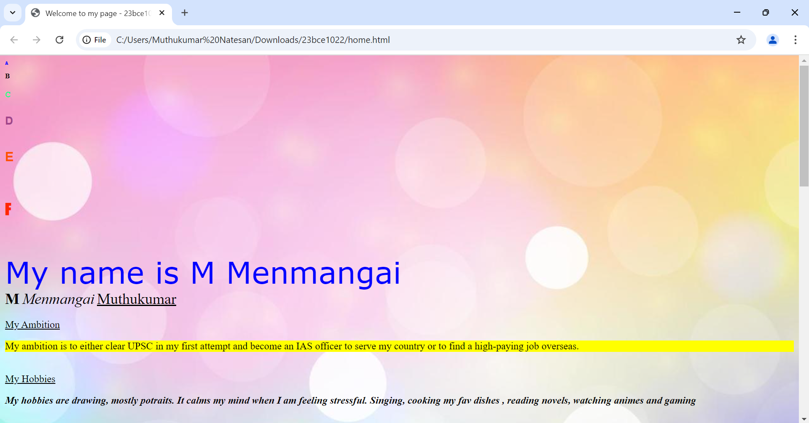

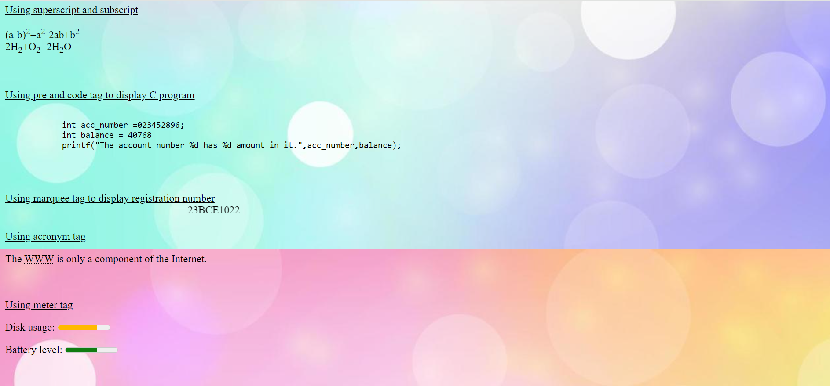 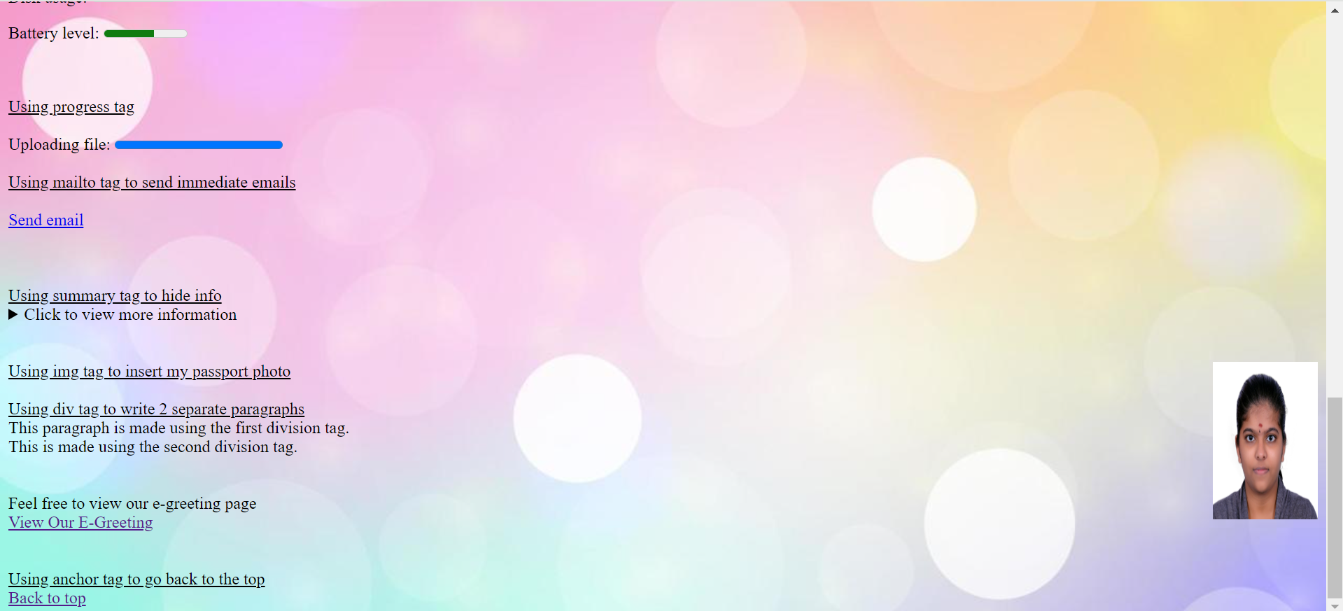

**2) Design an E-Greeting page (greeting.html) that is properly aligned using semantic tags.**

**Provide links from the home page to the greeting page and vice versa**

**CODE:**

**greeting.html**

<!DOCTYPE html>

<html>

<head>

    <title>Festive E-Greeting</title>

    <style>

        body {

            background-image: url('rainbow-bokeh-soft-light-abstract-background-eps-10-illustration-bokeh-particles-background-decoration-vector.jpg');

        }

    </style>

</head>

<body>

    <header>

        <h1 style="text-align: center;">✨ Special E-Greeting ✨</h1>

        <nav style="text-align: center;">

            <a href="home.html">← Back to Home</a>

        </nav>

    </header>

    <main style="text-align: center;">

        <article class="greeting-card">

            <h2 ><b>Happy Holidays!</b></h2>

            <p><b>✨ Wishing you boundless joy, endless laughter, and magical moments during this special season! ✨</p>

            <p>May your days be merry and bright! 🌟</b></p>

            <figure>

                <img style="text-align: center;" src="C:\Users\Muthukumar Natesan\Downloads\23bce1022\gladwins-farm-new-years-eve.webp" alt="Holiday decoration">

                <figcaption><b>✨ Season's Greetings ✨</b></figcaption>

            </figure>

        </article>

    </main>

    <footer style="text-align: center;background-color: blue;">

        <p>✨ &copy; Mangai Website. All Rights Reserved. ✨</p>

    </footer>

</body>

</html>

**OUTPUT:**

 

